Day 2 Disneyland Itinerary (Most Info Unavailable this far in advance)

Park opens at 8:00 and closes at 12:00 in past years around the 17-20th of December.

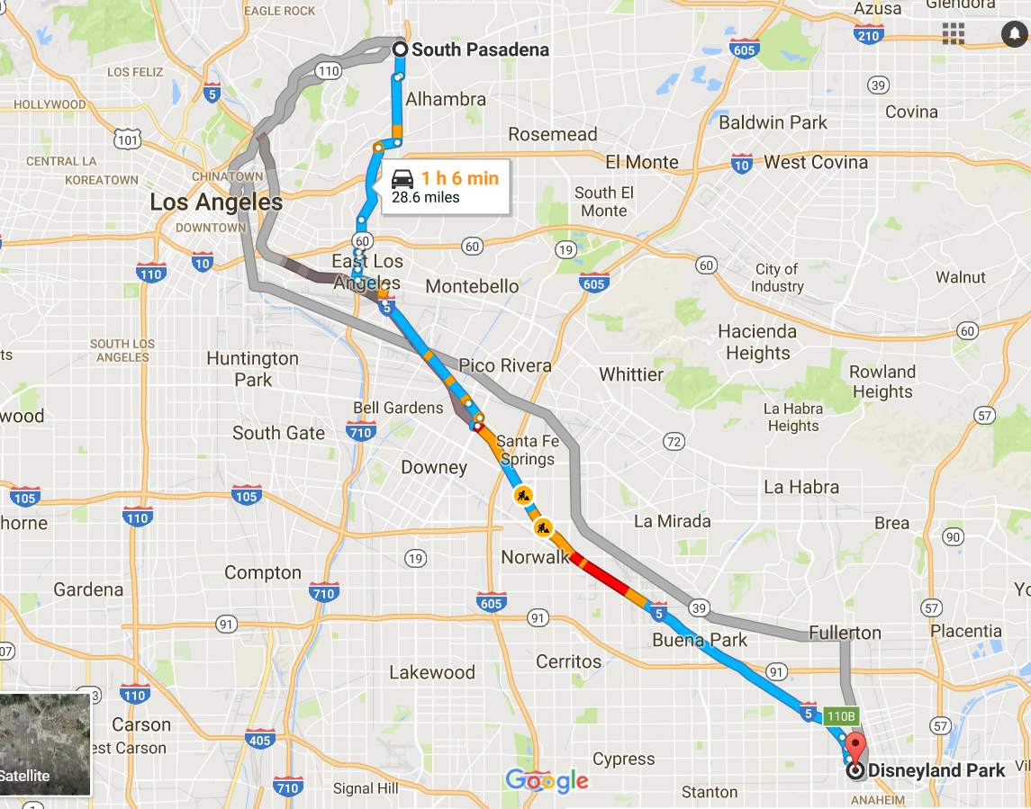

6:45 – 7:00 am

Leave for Disneyland.

8:00 am

Arrive. Eat Breakfast at Carnation Café at Main Street.

12:00 pm

Lunch at Bengal Barbecue at Adventureland.

5:00 pm

Fantasmic! Dining Packages at Blue Bayou at New Orleans Square.

9:30 pm

Fireworks show!

11:00 pm – 12:00 am

Leave for home.

12:00 am – 1:00 am

Arrive home.